BookStack
Technical Description
November 2024

Contents
1. Document Control 3
1.1. Revision History 3
1.2. Document Review and Approval 3
1.3. Acronyms 3
1.4. References 3
2. Introduction 3
2.1. Document Purpose 3
2.2. Solution Overview 3
2.3. Architecture Overview 4
2.4. Responsibility Matrix 4

Document Control

Revision History
Version | Author | Date (dd/mm/yyyy) | Summary of change
1.0 | Ivan Ivanov | 24.11.2024 | Initial version
1.1 | Ivan Ivanov | 27.12.2024 | Updated architecture overview (section 2.5)

Document Review and Approval
Version | Approved by | Date (dd/mm/yyyy)
1.0 | Petr Petrov | 22.11.2024
1.1 | Petr Petrov | 23.12.2024

Acronyms
Acronym | Definition
ADFS | Active Directory Federation Service

References
Item no. | Document title | Version or date
1 | Source repository README | Managed by vendor
2

Introduction

Document Purpose
The document is intended as a reference for system administrators and support engineers in charge of the system deployment and maintenance.

Solution Overview
BookStack is an opinionated documentation platform that provides a pleasant and simple out-of-the-box experience. New users to an instance should find the experience intuitive and only basic word-processing skills should be required to get involved in creating content on BookStack. The platform should provide advanced power features to those that desire it, but they should not interfere with the core simple user experience.
The BookStack source is provided under the MIT License.
The libraries used by, and included with, BookStack are provided under their own licenses and copyright. The licenses for many of our core dependencies can be found in the attribution list below but this is not an exhaustive list of all projects used within BookStack.

Architecture Overview
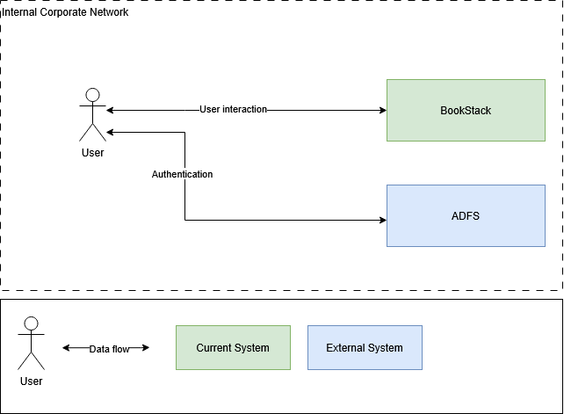

Data flow description:

Data flow | Source | Destination | Schedule
User interaction | User | BookStack | On user query
User interaction | BookStack | User | On user query
Authentication | User | ADFS | On user query
Authentication | ADFS | User | On user query

Responsibility Matrix
System | Vendor | Administrator
BookStack | BookStack | Ivan Ivanov
ADFS | Microsoft | Sergey Sergeev

